# Jack Dorsey Biography

Jack Dorsey is most famously known as the co-founder and chief executive officer of Twitter and the founder and CEO of Square. Twitter is one of the largest social media platforms having 330 million monthly active users. Square is a mobile payment company. Square is a device which can be plugged into mobile phones and computers to receive credit card payments.

Figure : Jack Dorsey, the Founder of Twitter

## EARLY LIFE

Jack Dorsey was born in St Louis, Missouri on the 19th of November 1976. Being raised by a strongly Catholic family, Dorsey is of English, Irish and Italian descent, he attended Bishop DuBourg High School, a Catholic high school in St Louis. While at the school he developed a keen interest in computers and communications, particularly dispatch routing. Dorsey was intrigued by the challenge posed by the coordination of taxi drivers, delivery vans and other such fleets of vehicles that require to always be in constant and rapid communication with one another. With this in mind, young Dorsey began to program his own vehicle dispatch software at the ripe age of 15. The software written by the promising young software designer is still being used by many taxi companies to this day.

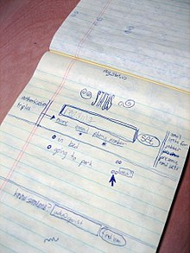After high school Dorsey attended the University of Missouri-Rolla for two years before transferring to New York University. Dorsey did not complete his course in NYU, however, dropping out just a mere semester short of graduating. He moved from New York to Oakland, California in 1999 where he began a company that implemented the software he created while at high school for dispatch routing. In the year 2000 inspiration struck and Dorsey began to consider instant messaging as a convenient way to keep in touch with friends.

Figure : In 2006 Jack Dorsey drew this sketch to show how envisioned Twitter to look

## CREATION OF TWITTER

Six years after having his brainwave, Dorsey approached Evan Williams and Christopher Stone with the idea of a social networking site based on the user’s status. Together the three men developed the first version of the Twitter platform, back then it was known as Obvious. It took Dorsey two weeks to develop the site where users could post status updates of at most 140 characters which would come to be known as tweets. Dorsey posted the first ever tweet on the 21st of March 2006 – “just setting up my twttr”. The site rapidly grew in popularity, becoming both a platform for social networking but also a major medium for communication by the world at large.

## THE GROWTH OF TWITTER

From the off, Twitter’s popularity grew rapidly. In 2007, 400,000 tweets were posted per quarter. By 2008, this figure had grown to 100 million tweets per quarter. According to Twitter, in June 2010 65 million tweets were being posted per day equating to approximately 750 tweets per second. By 2012, more thn 100 million users posted 340 million tweets a day and these figures continue to grow. As it stands, Twitter has 134 million daily active users. The site is still used by people to post their regular status updates but Twitter now also plays a major role in some of the world’s largest events. In 2009 when the US Airways plane crased into the Hudson River in New York City Twitter gained recognition as th emost prominent news breaking social media platform. The news of the crash began to spread like wildfire as New York based twitter users began to live tweet about the crash based on what they could see from their windows. Twitter also plays a major role in modern politics. There is an endless amount of evidence for this trend on the site itself. Just search the hashtag #Brexit on Twitter and millions of tweets will appear. Politicians themselves are also avid users of the social media platform. During the 2008 general election in the United States, Barack Obama made 261 tweets. Obama has 109.1 million followers. The current president of the United States, one Donald Trump tweets almost every day. He has 65.4 million followers. Twitter is also popular among the rich and famous. Celebrities use Twitter to both advertise their current projects and to engage with their fans. My personal favourite celebrity on Twitter is Chrissy Tiegen (@chrissytiegen). She recently found herself in a Twitter spat with Donald Trump after he referred to her and her husband John Legend as “boring musician John Legend, and his filthy mouthed wife”. Dorsey himself has 4.2 million followers on Twitter and his username is simply @jack. One of the advantages of being the original user I presume. Dorsey’s favourite Twitter user is one Elon Musk who he describes as being “focused on solving existential problems and sharing his thinking openly.”

## SQUARE INCORPORATED

In 2010, Dorsey became an investor in the social networking company Foursquare. He took it upon himself to launch a new venture, Square alongside his fellow entrepreneur Jim McKelvey. The pair wanted to create a company that would aggregate merchant services 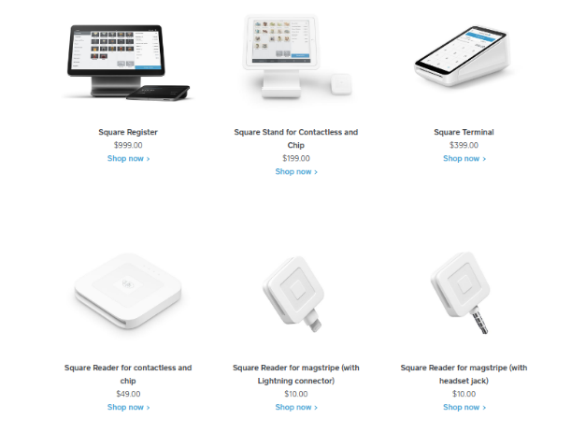and mobile payments into a single, practical service. The company markets several software and hardware payment products and has expanded into small business services. The first product produced by the company was The Square Reader. This is a device that connects to a mobile’s audio jack and accepts credit card payments through it. Dorsey and McKelvey were inspired to create this product when McKelvey was unable to complete a $2000 sale of glass faucets because he could not accept credit cards. The Square Reader was launched in 2010. The devices produced by Square Inc. are run in conjunction with the 5 Square applications: Square Point of Sale, Square for Retail, Square Appointments, Square Online Store and Square for Restaurants. In 2013 the company announced the launch of the Square Stand. This product consists of an iPad which is especially converted into an extremely efficient and aesthetic point of sale system which accepts contactless and chip payments. Other devices produced by the firm include the Square Register, purpose built for the Square Point of Sale application, the Square Terminal, a handheld device that features a display, prints receipts and accepts chip, swipe and contactless payments. Business Insider has praised the product for its “ease of use, simplicity and elegance”. The product has become increasingly popular among young entrepreneurs, mostly in the restaurant industry. In 2018, Square’s revenue was US$3.299 billion.

Figure : The different devices produced by Square Inc.

## CONCLUSION

Presently, Dorsey lives in the Sea Cliff neighbourhood of San Francisco. He walks to work every day to clear his head before a busy day at the office. His newest aspiration in life is to become the mayor of New York City, he’ll undoubtedly put Twitter to use in his campaign! I find Jack Dorsey to be an inspiration because of the vast amount that he achieved at such a young age. In 2008, at the age of 32 he was names as one of the top 35 innovators in the world under the age of 35 by the MIT Technology Review. At 36 he received the “Innovator of the Year Award” for technology by the Wall Street Journal. In the same year he was named “Founder of the Year” by Tech Crunch at the Annual Crunchies Awards. At present, Dorsey is estimated to have a net worth of US$4.1 billion.

## Bibliography

* <https://www.businessinsider.com/fabulous-life-of-billionaire-jack-dorsey-taking-square-public?r=US&IR=T#hes-a-big-believer-in-cryptocurrency-frequently-tweeting-about-its-virtues-30>
* <https://squareup.com/us/en>
* <https://en.wikipedia.org/wiki/Square,_Inc.>
* <https://en.wikipedia.org/wiki/Use_of_Twitter_by_public_figures#Politicians>
* <https://www.telegraph.co.uk/technology/twitter/4269765/New-York-plane-crash-Twitter-breaks-the-news-again.html>
* <https://www.brandwatch.com/blog/twitter-stats-and-statistics/>
* <https://www.britannica.com/biography/Jack-Dorsey>
* <https://www.biography.com/business-figure/jack-dorsey>
* <https://en.wikipedia.org/wiki/Jack_Dorsey>